# BadgeScan

**To test the app**

1. **Configure the application manually or using the QR code**
   1. **Manually Setup**  
      *D365 Hostname*: bwctst2.crm4.dynamics.com  
      *Application Id*: 99a5b7d5-10a8-4065-bcb1-6397784407bd  
      *Contact Attribute*: employeeid  
      *Use Barcode Scanner*: true
   2. **Setup using QR Code**

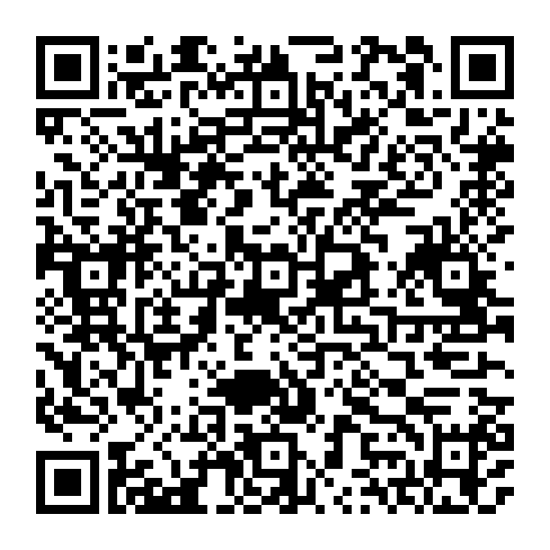

1. **Scan any of the barcodes below to show a sample contact**  
   *Photos and names shown are fake*

